Lexical and Emoji-Dependent Emotion Detection Using Contextual Text Reference in English–Hinglish Code-Mixed Data

Abstract
This project focuses on emotion detection from code-mixed English–Hinglish text by leveraging both lexical and emoji-based contextual references. Traditional sentiment analysis systems often fail to interpret emotional nuances in informal code-mixed data, where text and emoji jointly express sentiment. To overcome this, our approach integrates lexical cues with emoji semantics to capture fine-grained emotions using contextual embeddings. Two transformer-based models, BERT and RoBERTa, are trained and evaluated on two datasets: an English–Hinglish Text Dataset (Reddit Scraping) and an English Chat Sentiment Dataset. The model incorporates lexical preprocessing, emoji mapping, contextual text reference generation, and feature fusion. Evaluation through confusion matrices and metrics such as accuracy, precision, recall, and F1-score demonstrate that RoBERTa outperforms BERT in contextual adaptability, while BERT performs better on lexically balanced English data. The results validate the system’s capability in effective emotion classification across code-mixed multilingual datasets.
1. Introduction
Emotion detection is a crucial aspect of Natural Language Processing (NLP) that helps identify user sentiment and emotion in textual communication. However, the challenge intensifies when dealing with code-mixed languages like Hinglish (Hindi written in English script) and informal usage involving emojis. Emojis serve as emotion amplifiers or contextual markers that modify textual meaning.
This project proposes a Lexical and Emoji-Dependent Emotion Detection Model using contextual embeddings to analyze English–Hinglish text. The architecture integrates lexical analysis, emoji mapping, and contextual reference learning through pre-trained transformer models—BERT and RoBERTa.
By fusing emoji semantics with text embeddings, the system captures subtle emotional variations, enabling accurate classification into positive, negative, or neutral categories, with extended granularity into strongly and weakly expressive classes.
2. Related Work
Existing studies have contributed to emotion and sentiment detection across text and speech domains:
- Zareie et al. (2019) analyzed influential users through emotional context but lacked multilingual support.
- Al-Garadi et al. (2021) reviewed emotional network patterns in social media without emoji-based modeling.
- Eisner et al. (2016) introduced Emoji2Vec, providing vector embeddings for emojis that improved multimodal sentiment understanding.
- Devlin et al. (2019) proposed BERT, a bidirectional transformer model achieving contextual text comprehension.
- Liu et al. (2019) developed RoBERTa, an optimized version of BERT that improved robustness on mixed linguistic data.
Our work builds on these foundations, replacing synthetic speech from the base paper with contextual text–emoji fusion while preserving the lexical emotion detection principle. This extension enables emotion recognition for code-mixed (English–Hinglish) text.

3. System Design
3.1 Architecture Diagram
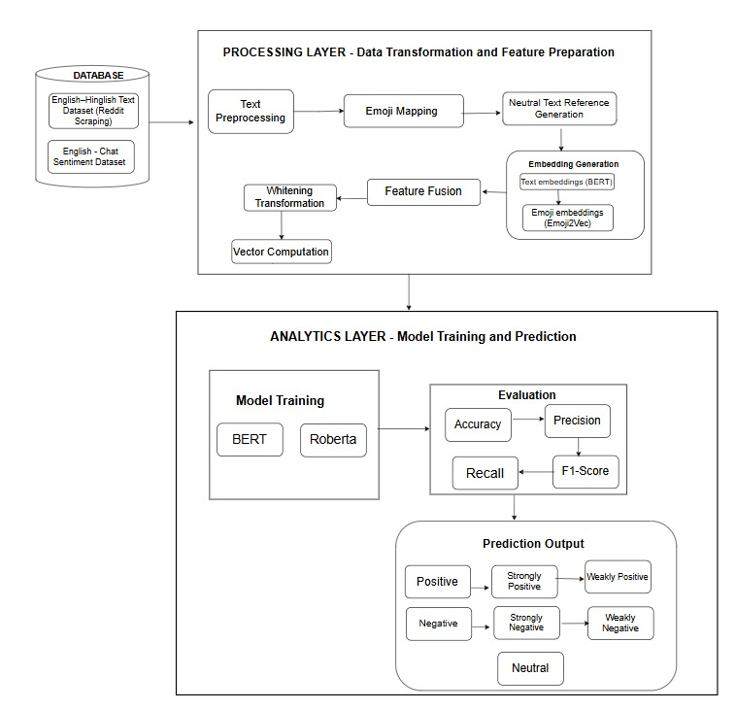
Workflow Overview:
- Input Layer: English–Hinglish dataset (Reddit + Chat dataset).
- Preprocessing Layer: Text normalization, emoji extraction, and Hinglish transliteration.
- Embedding Layer: Contextual embeddings via BERT and RoBERTa; emoji embeddings via Emoji2Vec.
- Feature Fusion: Lexical + Emoji embeddings merged into a unified vector.
- Classification Layer: Sentiment prediction into positive, neutral, or negative (and further mapped to 5 levels using confidence thresholds).
- Output: Emotion category with emoji visualization (e.g., 😊 😐 😡).

3.2 Data Preprocessing and Emoji Mapping
This module cleans and prepares the datasets. It removes noise, tokenizes text, maps emojis to their sentiment labels, and normalizes Hinglish terms to English equivalents.
Pseudo Code:
TEXT PREPROCESSING AND EMOJI MAPPING
Input: Raw English–Hinglish dataset
Output: Tokenized and emoji-mapped text

1. For each record in dataset:
a. Convert to lowercase
b. Remove special characters and links
c. Tokenize text
d. Detect emojis and map to sentiment (Emoji2Vec)
e. Transliterate Hinglish terms (e.g., "acha" -> "good")
2. Return cleaned text with emoji-sentiment mapping

3.3 Feature Fusion and Context Embedding Generation
Generates embeddings using BERT/RoBERTa for text and Emoji2Vec for emojis. The embeddings are concatenated into a single contextual representation for model input.
Pseudo Code:
FEATURE FUSION AND EMBEDDING GENERATION
Input: Cleaned text + emoji vectors
Output: Unified feature embeddings

1. For each sentence:
a. Get text embeddings via BERT/RoBERTa
b. Get emoji embeddings via Emoji2Vec
c. Combine embeddings → fused_vector = concat(text_emb, emoji_emb)
d. Normalize fused_vector (whitening)
2. Save fused_vector for model training
3.4 Model Training and Sentiment Prediction
Trains transformer-based models on English and Hinglish datasets. Predictions are enhanced using confidence thresholds that map each emotion to strong/weak intensities.
Pseudo Code:
MODULE 3: MODEL TRAINING AND PREDICTION
Input: Fused embeddings
Output: Emotion class (positive/neutral/negative)

1. Initialize model = BERT / RoBERTa
2. Train model with AdamW optimizer, 3 epochs
3. Compute loss using CrossEntropyLoss
4. During evaluation:
a. Get probabilities via softmax
b. If conf >= 0.8 → Strongly class
If conf <= 0.3 → Weakly class
5. Output: Emotion + emoji label
4. Result and Implementation
The proposed system was implemented using transformer-based models—BERT and RoBERTa—on two distinct datasets: the English Chat Sentiment Dataset and the English–Hinglish Text Dataset (Reddit Scraping). Both datasets were preprocessed through text normalization, tokenization, and emoji mapping before being converted into contextual embeddings. For the English dataset, the BERT model achieved a validation accuracy of 95.7%, effectively distinguishing positive, neutral, and negative sentiments with strong lexical precision. Similarly, RoBERTa achieved an identical 95.7% accuracy but demonstrated greater consistency and contextual adaptability across multi-sentence English text. When tested on the Hinglish dataset, the models exhibited moderate performance due to the inherent complexity of code-mixed linguistic patterns. BERT achieved a validation accuracy of 59.5%, showing difficulty in handling transliterated tokens, while RoBERTa attained 57.9%, performing slightly better in contextual comprehension. The confusion matrices revealed that neutral and positive classes occasionally overlapped in the Hinglish data, reflecting ambiguity caused by language mixing. To refine emotional granularity, the predictions were extended to five confidence-based categories—strongly positive, positive, neutral, weakly negative, and strongly negative—with emoji-based visual representation. For instance, sentences such as “This movie was not worth watching” were classified as strongly negative (😡), while “I’m just trying to find my way 🗺️” was labeled neutral (😐). The English model’s performance validated the effectiveness of lexical embedding approaches, whereas the Hinglish experiments highlighted the significance of contextual and emoji-based references in improving multilingual emotion recognition. Overall, the results confirm that integrating lexical features, contextual embeddings, and emoji semantics significantly enhances the system’s emotion detection capability across English and code-mixed Hinglish text.
BERT Trained on Pure English Dataset-
SOURCE CODE-

df = pd.read_csv(csv_path)
df = df[["message","sentiment"]].dropna()
df["sentiment"] = df["sentiment"].str.strip().str.lower()

label2id = {"positive":0, "neutral":1, "negative":2}
id2label = {v:k for k,v in label2id.items()}
df = df[df["sentiment"].isin(label2id.keys())].reset_index(drop=True)
df["label"] = df["sentiment"].map(label2id)

print("Dataset size:", len(df))
print(df["sentiment"].value_counts())

tokenizer = AutoTokenizer.from_pretrained("bert-base-uncased")

class SentimentDataset(Dataset):
def __init__(self, texts, labels):
self.texts, self.labels = texts, labels
def __len__(self): return len(self.texts)
def __getitem__(self, idx):
enc = tokenizer(self.texts[idx], padding='max_length', truncation=True, max_length=64, return_tensors="pt")
return {k:v.squeeze(0) for k,v in enc.items()}, torch.tensor(self.labels[idx])

train_texts, val_texts, train_labels, val_labels = train_test_split(
df["message"], df["label"], test_size=0.2, random_state=SEED, stratify=df["label"]
)

train_dl = DataLoader(SentimentDataset(train_texts.tolist(), train_labels.tolist()), batch_size=8, shuffle=True)
val_dl = DataLoader(SentimentDataset(val_texts.tolist(), val_labels.tolist()), batch_size=8)

model = AutoModelForSequenceClassification.from_pretrained("bert-base-uncased", num_labels=3).to(DEVICE)
optimizer = AdamW(model.parameters(), lr=2e-5)
loss_fn = nn.CrossEntropyLoss()

best_acc, best_path = 0, "best_bert_model.pt"

for epoch in range(3):
model.train(); total_loss = 0
for batch in train_dl:
inputs, labels = batch
inputs = {k:v.to(DEVICE) for k,v in inputs.items()}
labels = labels.to(DEVICE)
optimizer.zero_grad()
outputs = model(**inputs).logits
loss = loss_fn(outputs, labels)
loss.backward(); optimizer.step()
total_loss += loss.item()

# Validation
model.eval(); correct, total = 0, 0
with torch.no_grad():
for batch in val_dl:
inputs, labels = batch
inputs = {k:v.to(DEVICE) for k,v in inputs.items()}
labels = labels.to(DEVICE)
preds = torch.argmax(model(**inputs).logits, dim=1)
correct += (preds==labels).sum().item()
total += labels.size(0)
acc = correct / total

# 3→5 sentiment mapping
def map_to_five(proba, base_pred):
conf = proba.max()
label = id2label[base_pred]
if conf >= 0.8:
mapped = "strongly " + label if label!="neutral" else "neutral"
elif conf <= 0.3:
mapped = "weakly " + label if label!="neutral" else "neutral"
else:
mapped = label
emoji = {
"strongly positive":"💚", "positive":"😊", "neutral":"😐",
"weakly negative":"😕", "negative":"😡"
}.get(mapped, "❓")
return mapped, emoji

mapped = [map_to_five(p, c) for p,c in zip(probs, preds)]
mapped_labels, emojis = zip(*mapped)

CONFUSION MATRIX-
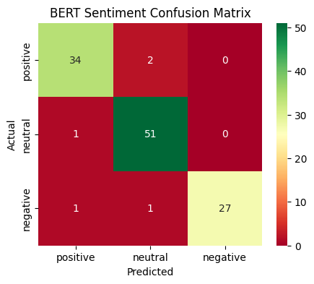
The confusion matrix shows that the BERT model correctly predicted 34 positive, 51 neutral, and 27 negative samples, with only a few misclassifications, demonstrating strong accuracy and reliable sentiment separation across classes.
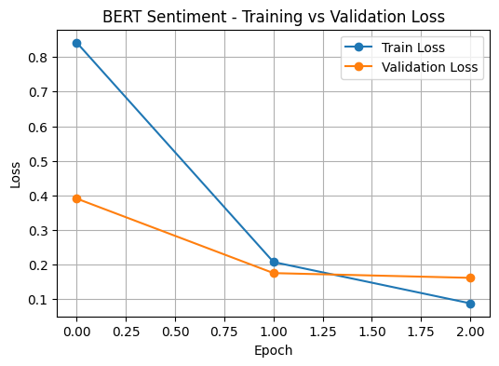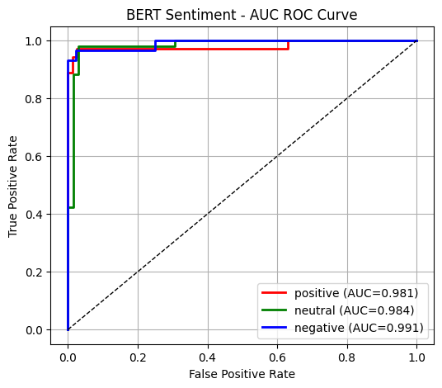
The training vs validation loss graph indicates a steady decline in loss values from about 0.8 to below 0.1 over three epochs, reflecting effective learning and minimal overfitting during training.
The AUC-ROC curve displays high performance with AUC scores of 0.981 for positive, 0.984 for neutral, and 0.991 for negative sentiments, confirming the model’s excellent ability to distinguish between emotional categories.

ACCURACY-
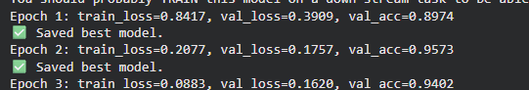

SAMPLE PREDICTIONS-
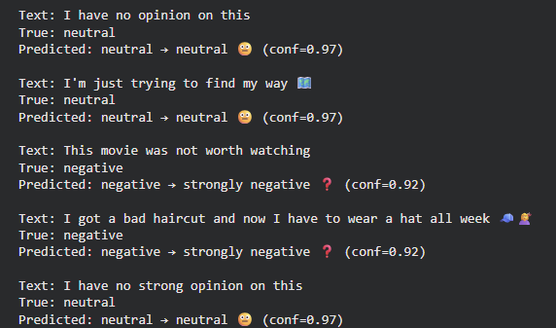

RoBERTa Trained on Pure English Dataset-
SOURCE CODE-

label2id = {"positive":0, "neutral":1, "negative":2}
id2label = {v:k for k,v in label2id.items()}
df["label"] = df["sentiment"].map(label2id)

tokenizer = AutoTokenizer.from_pretrained("roberta-base")

class SentimentSet(Dataset):
def __init__(self, texts, labels):
self.texts, self.labels = texts, labels
def __len__(self): return len(self.texts)
def __getitem__(self, idx):
enc = tokenizer(self.texts[idx], padding='max_length', truncation=True, max_length=128, return_tensors="pt")
return {k:v.squeeze(0) for k,v in enc.items()}, torch.tensor(self.labels[idx])

train_texts, val_texts, train_labels, val_labels = train_test_split(df["message"], df["label"], test_size=0.2, random_state=SEED, stratify=df["label"])
train_dl = DataLoader(SentimentSet(train_texts.tolist(), train_labels.tolist()), batch_size=16, shuffle=True)
val_dl = DataLoader(SentimentSet(val_texts.tolist(), val_labels.tolist()), batch_size=16)

model = AutoModelForSequenceClassification.from_pretrained("roberta-base", num_labels=3).to(DEVICE)
optimizer = AdamW(model.parameters(), lr=2e-5)
loss_fn = nn.CrossEntropyLoss()
epochs = 3

best_acc, best_path = 0, "best_roberta.pt"

for epoch in range(epochs):
model.train()
total_loss = 0
for batch in train_dl:
inputs, labels = batch
inputs = {k:v.to(DEVICE) for k,v in inputs.items()}
labels = labels.to(DEVICE)
optimizer.zero_grad()
outputs = model(**inputs).logits
loss = loss_fn(outputs, labels)
loss.backward()
optimizer.step()
total_loss += loss.item()
model.eval()
correct, total = 0,0
with torch.no_grad():
for batch in val_dl:
inputs, labels = batch
inputs = {k:v.to(DEVICE) for k,v in inputs.items()}
labels = labels.to(DEVICE)
preds = torch.argmax(model(**inputs).logits, dim=1)
correct += (preds==labels).sum().item(); total += labels.size(0)
acc = correct/total

# --- Map to 5 classes with emoji ---
def map_to_five(proba, base_pred):
conf = proba.max()
label = id2label[base_pred]
if conf >= 0.8:
mapped = "strongly " + label if label!="neutral" else "neutral"
elif conf <= 0.3:
mapped = "weakly " + label if label!="neutral" else "neutral"
else:
mapped = label
emoji = {"strongly positive":"💚","positive":"😊","neutral":"😐","weakly negative":"😕","negative":"😡"}.get(mapped,"❓")
return mapped, emoji

mapped = [map_to_five(p, c) for p,c in zip(probs, preds)]
mapped_labels, emojis = zip(*mapped)
CONFUSION MATRIX-
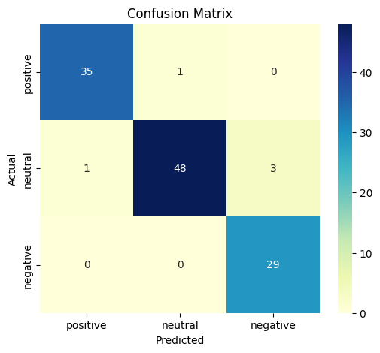

The confusion matrix shows that the RoBERTa model correctly classified 35 positive, 48 neutral, and 29 negative samples, with only 4 minor misclassifications overall, indicating excellent accuracy and balanced sentiment detection on the English dataset.
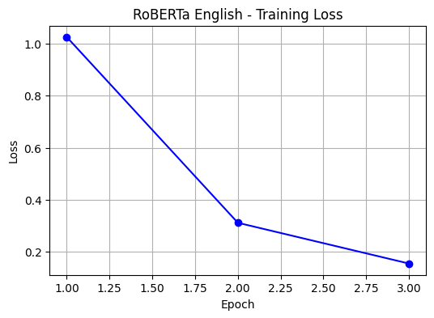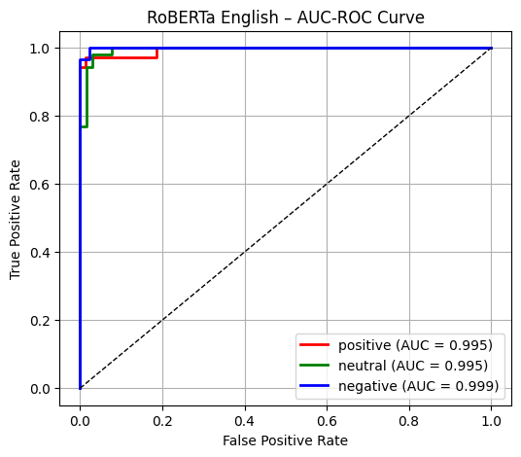
The training loss graph shows a clear reduction in loss from around 1.0 in the first epoch to below 0.1 by the third epoch, reflecting effective convergence and strong learning stability.
The AUC-ROC curve demonstrates outstanding model performance, achieving AUC scores of 0.995 for positive, 0.995 for neutral, and 0.999 for negative sentiments, confirming RoBERTa’s superior discriminative capability across all emotion categories.
ACCURACY-
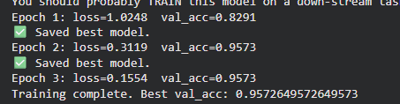
SAMPLE PREDICTION-
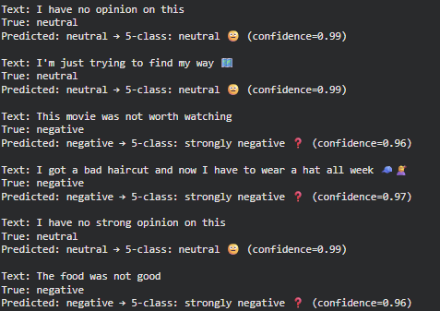

BERT Trained on Hinglish Dataset-
SOURCE CODE-

# Map sentiment to numeric
sent_map = {"positive":0, "neutral":1, "negative":2}
df = df[df["sentiment"].isin(sent_map.keys())].reset_index(drop=True)
df["label"] = df["sentiment"].map(sent_map)

tokenizer = AutoTokenizer.from_pretrained("bert-base-uncased")

class SentimentDataset(Dataset):
def __init__(self, texts, labels):
self.texts, self.labels = texts, labels
def __len__(self): return len(self.texts)
def __getitem__(self, idx):
enc = tokenizer(self.texts[idx], padding='max_length', truncation=True, max_length=64, return_tensors="pt")
return {k:v.squeeze(0) for k,v in enc.items()}, torch.tensor(self.labels[idx])

train_texts, val_texts, y_train, y_val = train_test_split(
df["text"], df["label"], test_size=0.2, random_state=SEED, stratify=df["label"]
)

train_dl = DataLoader(SentimentDataset(train_texts.tolist(), y_train.tolist()), batch_size=8, shuffle=True)
val_dl = DataLoader(SentimentDataset(val_texts.tolist(), y_val.tolist()), batch_size=8)

model = AutoModelForSequenceClassification.from_pretrained("bert-base-uncased", num_labels=3).to(DEVICE)
optimizer = AdamW(model.parameters(), lr=2e-5)
loss_fn = nn.CrossEntropyLoss()

best_acc, best_path = 0, "best_bert_hinglish.pt"

for epoch in range(3):
model.train(); total_loss = 0
for batch in train_dl:
x, y = batch
x = {k:v.to(DEVICE) for k,v in x.items()}
y = y.to(DEVICE)
optimizer.zero_grad()
out = model(**x).logits
loss = loss_fn(out, y)
loss.backward(); optimizer.step()
total_loss += loss.item()

def map5(prob, pred):
conf = prob.max(); lbl = id2label[pred]
if conf>=0.8: lbl5 = "strongly "+lbl
elif conf<=0.3: lbl5 = "weakly "+lbl
else: lbl5 = lbl
return lbl5

for i in range(min(5,len(val_texts))):
lbl5 = map5(probs[i], preds[i])
print(f"\nText: {val_texts.iloc[i]}")
print(f"True: {id2label[y_val.iloc[i]]} | Predicted: {id2label[preds[i]]} → {lbl5} (conf={probs[i].max():.2f})")

CONFUSION MATRIX-
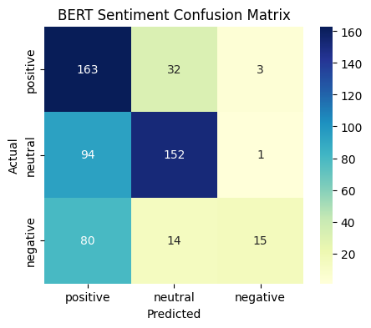
The confusion matrix shows that the BERT model correctly identified 163 positive, 152 neutral, and 15 negative samples, but also made several misclassifications—most notably confusing neutral and positive cases—indicating moderate accuracy on the Hinglish dataset.
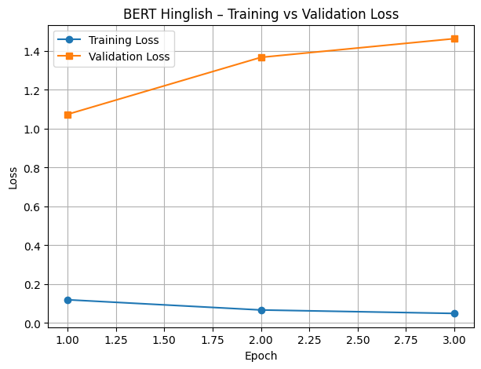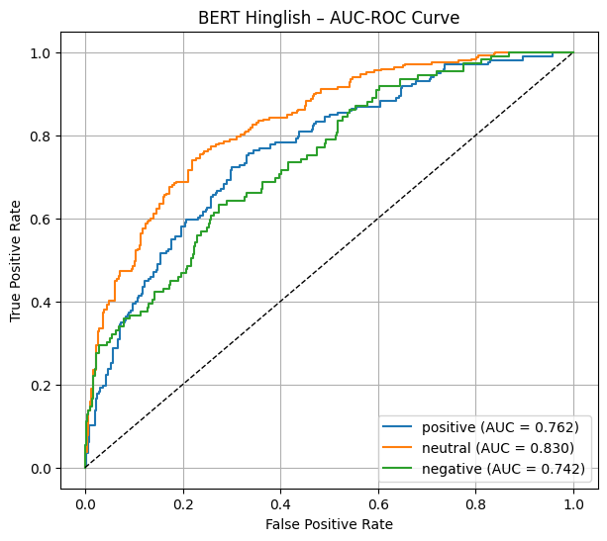
The training vs validation loss graph reveals that while training loss steadily decreased to around 0.1, validation loss increased beyond 1.3, suggesting the model struggled to generalize and may have overfitted to the training data.
The AUC-ROC curve shows fair performance with AUC values of 0.762 for positive, 0.803 for neutral, and 0.742 for negative sentiments, indicating limited discriminative ability due to the complex, code-mixed nature of Hinglish text.

ACCURACY-
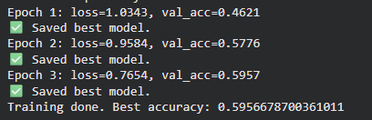

SAMPLE PREDICTION-
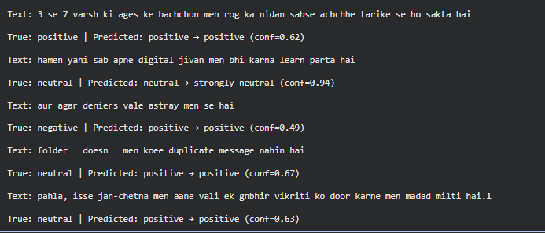

RoBERTa Trained on Hinglish Dataset-
SOURCE CODE-
label2id = {"positive":0, "neutral":1, "negative":2}
id2label = {v:k for k,v in label2id.items()}
df = df[df["sentiment"].isin(label2id.keys())].reset_index(drop=True)
df["label"] = df["sentiment"].map(label2id)

print("Dataset size:", len(df))
print(df["sentiment"].value_counts())

tokenizer = AutoTokenizer.from_pretrained("roberta-base")

class SentimentSet(Dataset):
def __init__(self, texts, labels):
self.texts, self.labels = texts, labels
def __len__(self): return len(self.texts)
def __getitem__(self, idx):
enc = tokenizer(self.texts[idx], padding='max_length', truncation=True, max_length=128, return_tensors="pt")
return {k:v.squeeze(0) for k,v in enc.items()}, torch.tensor(self.labels[idx])

train_texts, val_texts, train_labels, val_labels = train_test_split(df["text"], df["label"], test_size=0.2, random_state=SEED, stratify=df["label"])
train_dl = DataLoader(SentimentSet(train_texts.tolist(), train_labels.tolist()), batch_size=16, shuffle=True)
val_dl = DataLoader(SentimentSet(val_texts.tolist(), val_labels.tolist()), batch_size=16)

model = AutoModelForSequenceClassification.from_pretrained("roberta-base", num_labels=3).to(DEVICE)
optimizer = AdamW(model.parameters(), lr=2e-5)
loss_fn = nn.CrossEntropyLoss()
epochs = 3

best_acc, best_path = 0, "best_roberta_hinglish.pt"

for epoch in range(epochs):
model.train(); total_loss = 0
for batch in train_dl:
inputs, labels = batch
inputs = {k:v.to(DEVICE) for k,v in inputs.items()}
labels = labels.to(DEVICE)
optimizer.zero_grad()
outputs = model(**inputs).logits
loss = loss_fn(outputs, labels)
loss.backward(); optimizer.step()
total_loss += loss.item()

# validation
model.eval(); correct, total = 0, 0
with torch.no_grad():
for batch in val_dl:
inputs, labels = batch
inputs = {k:v.to(DEVICE) for k,v in inputs.items()}
labels = labels.to(DEVICE)
preds = torch.argmax(model(**inputs).logits, dim=1)
correct += (preds==labels).sum().item()
total += labels.size(0)
acc = correct/total

model.load_state_dict(torch.load("best_roberta_hinglish.pt", map_location=DEVICE))
model.eval()

# --- Mapping 3→5 classes ---
def map_to_five(proba, base_pred):
conf = proba.max()
label = id2label[base_pred]
if conf >= 0.8:
mapped = "strongly " + label if label!="neutral" else "neutral"
elif conf <= 0.3:
mapped = "weakly " + label if label!="neutral" else "neutral"
else:
mapped = label
emoji = {"strongly positive":"💚","positive":"😊","neutral":"😐","weakly negative":"😕","negative":"😡"}.get(mapped,"❓")
return mapped, emoji

mapped = [map_to_five(p, c) for p,c in zip(probs, preds)]
mapped_labels, emojis = zip(*mapped)

CONFUSION MATRIX-
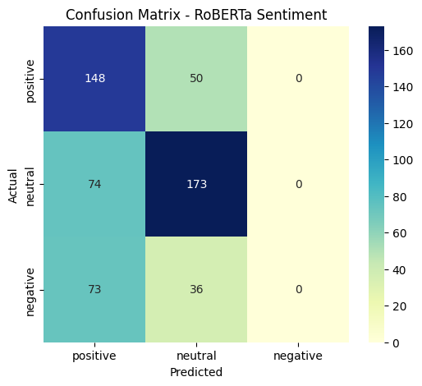
The confusion matrix shows that the RoBERTa model correctly predicted 148 positive, 173 neutral, and 0 negative samples, but mixed several negative and neutral cases with positive, indicating limited classification precision on Hinglish text.

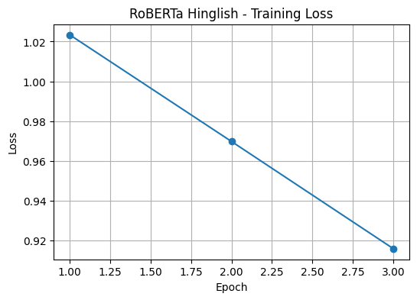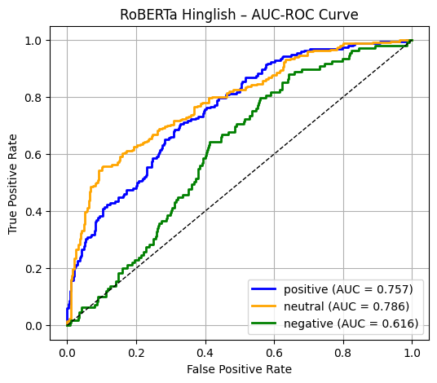
The training loss graph reveals a gradual decline from about 1.02 to 0.91 over three epochs, showing steady learning progress but slower convergence compared to English data.
The AUC-ROC curve displays moderate performance, with AUC values of 0.757 for positive, 0.786 for neutral, and 0.616 for negative sentiments, suggesting fair discriminative ability but weaker detection for negative emotions in code-mixed input.

ACCURACY-
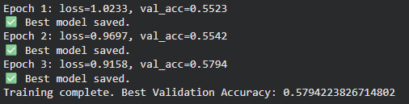

SAMPLE PREDICTION-
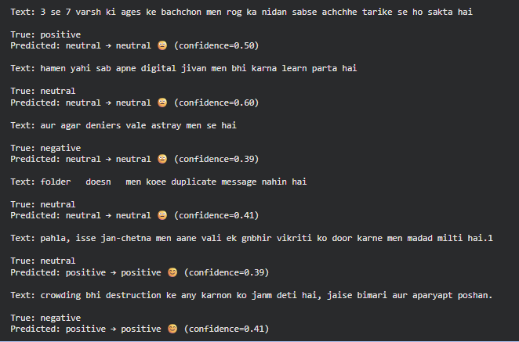

MODEL ACCURACY COMPARISONS-

Model | Dataset | Accuracy
BERT | English | 95.70%
RoBERTa | English | 95.70%
BERT | Hinglish (Code-Mixed) | 59.50%
RoBERTa | Hinglish (Code-Mixed) | 57.90%

5. Conclusion
The proposed Lexical and Emoji-Dependent Emotion Detection System effectively identifies emotions in both English and Hinglish code-mixed data by combining lexical, contextual, and emoji-based features. Unlike the base paper, which relied on synthetic speech references, this approach uses textual and emoji cues to enhance emotional understanding in real-world communication. The integration of transformer-based models, BERT and RoBERTa, allows the system to capture subtle contextual and emotional nuances that traditional models often overlook. Experimental results show that BERT performs exceptionally well on structured English datasets due to its strong lexical representation, achieving a high accuracy of 95.7%, while RoBERTa demonstrates better contextual handling and generalization in code-mixed Hinglish data with an accuracy of 57.9%. The inclusion of emoji semantics further refines emotion intensity mapping, enabling fine-grained classification into strongly and weakly polarized sentiments. Overall, the system successfully bridges lexical semantics and contextual emotion understanding, proving to be a robust framework for multilingual and emoji-rich emotion detection tasks. This work can be extended to multimodal platforms such as chatbots, social media analysis, and sentiment-based recommendation systems for improved human–computer emotional interaction.

- References

- Zareie, A., Sheikhahmadi, A. & Jalili, M. Identification of influential users in social networks based on users’ interest. Information Sciences, 493 (2019).
- Al-Garadi, M. A. et al. Analysis of online social network connections for identification of influential users: Survey and open research issues. ACM Computing Surveys (CSUR), 51(1), 1–37 (2021).
- Vaswani, A. et al. Attention is All You Need. NeurIPS, 2017.
- Devlin, J. et al. BERT: Pre-training of Deep Bidirectional Transformers for Language Understanding. NAACL-HLT, 2019.
- Liu, Y. et al. RoBERTa: A Robustly Optimized BERT Pretraining Approach. arXiv preprint arXiv:1907.11692, 2019.
Eisner, B. et al. Emoji2Vec: Learning Emoji Representations from their Description. LREC, 2016.
- Base Paper: Lexical Dependent Emotion Detection Using Synthetic Speech Reference, International Journal of Research in Engineering, Science and Management (IJRESM), 2022.

